Potential of Deep Sea Offshore Wind Energy
(2) Strom, Wärme-/Kälteerzeugung sowie Speicher
Lia Gruber⁽¹⁾, Robert Gaugl⁽²⁾ , Udo Bachhiesl⁽³⁾
⁽¹⁻³⁾ Technische Universität Graz,
Motivation und zentrale Fragestellung
If climate change worsens, nations across the world are enacting and attempting to meet aggressive carbon and clean energy goals in order to combat it. Only a large number of large-scale developments would be able to achieve those objectives. The analyzed power source has a high capacity factor, allowing it to provide both baseload and flexibility at the same time. Deep sea offshore wind has the potential to generate energy night and day and surplus capacity can be used to generate renewable hydrogen. The purpose of this work is to determine where the most suitable sites in Europe and Africa for this technology are situated.
Methodische Vorgangsweise
The Levelized Cost of Energy was defined as a starting point for the potential calculations. To avoid having a one-sided view on this, a few specific methods from the last few years were analyzed and compared. The forecasts for the next few decades, as well as the issues that the sector currently faces, are addressed. For the potential calculations, a system based on an Analytic Hierarchy Process developed by A. Bahaj at the University of Southampton ([1]) with the goal of developing a straightforward and reliable model is being used. Wind speed, water depth, distance to grid, and distance to shore are the factors that determine the potential in this approach. Nature reserves, under water cables, areas with wind speeds less than 5 m/s, and regions with water depths less than 60 m and greater than 1000 m are all omitted from the calculations. The factors' Levelized Cost of Energy (LCOE) shares are compared, and their factor weights are calculated. To compute the potential with a scale from 0-1, the factors are normalized before being multiplied by their factor weights and the Boolean mask derived from the restrictions.
Ergebnisse und Schlussfolgerungen
The results show that the majority of northern Europe, including vast parts of the Gulf of Bothnia, the coastal region surrounding Iceland and Ireland, as well as the North and Baltic seas, is ideal for deep sea offshore wind energy. Just a few high potential areas exist in the seas of southern Europe: Bretagne, south of France, north of Spain, and between Greece and Turkey. Africa's potential comprises primarily of small desirable sites spread throughout various regions, including Morocco, Madagascar, Mauritania, Senegal, and Eritrea. The only wide high potential region extends through South African and Namibian waters. To check the process's functionality, it was compared to potential calculations from the 2018 IEA Offshore Wind Outlook which in comparison is a yes/no potential, as well as commissioned and proposed wind farms. As no projects have yet been carried out in Africa, the second comparison was only carried out in Europe. As a consequence of this assessment, it is reasonable to assume that the model is functional. The simulation results closely match the outlook, and the majority of the projects are located in locations with significant deep water offshore potential.
Literatur
[1] A. S. Bahaj, M. Mahdy, A. S. Alghamdi, and D. J. Richards, “New approach to determine the Importance Index for developing offshore wind energy potential sites : Supported by UK and Arabian Peninsula case studies,” Renew. Energy, vol. 152, pp. 441–457, 2020, doi: 10.1016/j.renene.2019.12.070.

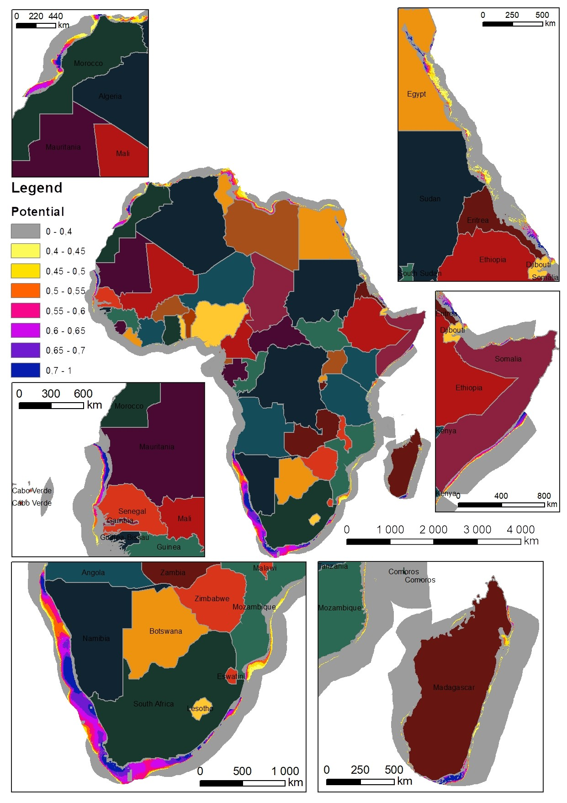
Abbildung 1: Deep sea offshore wind potential in Africa.
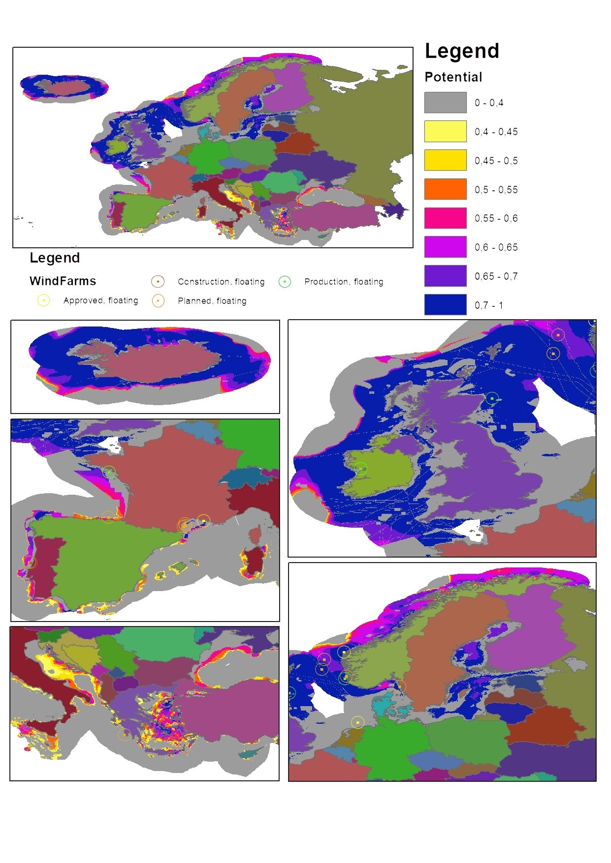
Abbildung 2: Deep sea offshore wind potential in Europe.

Jungautorin Inffeldgasse 18 8010 Graz +43 316 873 7909 lia.gruber@tugraz.com www.iee.tugraz.at

