An agent based modelling approach for estimating future energy demand in urban and rural areas

Subject area 3

Hannes KOCH[1](1), Marius FEULNER(1), Stefan LECHNER(1)

(1)Technische Hochschule Mittelhessen, Institut für Thermodynamik, Energieverfahrenstechnik und Systemanalyse, Wiesenstraße 14, 35390 Gießen

Motivation and research question

International efforts to drastically reduce greenhouse gas emissions have already agitated changes in the dynamics of municipal and supraregional energy systems. Falling prices for photovoltaics and the increase of decentralized energy supply pose planning challenges for distribution network operators and energy suppliers as temporal load charactistics and the amount of total energy demand will continue to change. In our work, we investigate a methodology to model the development of consumer-side technology compositions using Markov chains. We furthermore use this approach to map the effects of these processes onto a spatially and temporally resolved energy system model and analyze the outcome.

Methodology

Within a municipal energy supply system, the consumers are modelled as individual agents. For the area of study investigated[2], a GIS layer (geo information system) [1] containing detailed building information such as usage, electricity and heat demand [2] and rooftop photovoltaic potential (calculated based on LiDAR data [3]) is used to define one agent per building. In addition, a technology selection is generated for each sector (electricity, heat and mobility). Every agent within the system is then given periodic opportunities to carry out technology shifts for each of the sectors within which it acts as a consumer. The probabilities for shifting options are modeled as Markov transition matrices, as shown in Figure 1.

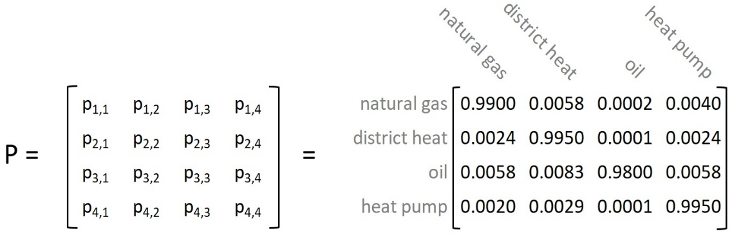

Figure 1: Transition matrix for shifting residential heating technologies. The probability to keep a given technology must be close to one in order not to cause unrealistic amounts of technology shifts (own representation)

Over a selectable period of time, this results in Markov chains for each agent. The technology selection depends on the usage category, so that industrial consumers naturally make different technology decisions than private residential buildings, for example. Furthermore, the probabilities for technology changes are based on technology prices. Non-economical decisions can be mapped using freely designable trend factors. When simulating the selected period of time, each consumer adapts their technology constellation according to their transition matrices. Subsequently, resulting energy requirements and load profiles are calculated.

Results and discussion

With the presented methodology, the effects of different factors such as cost developments, CO2 prices and fluctuations in renewable energies can be analyzed on a spatially and temporally highly resolved data basis. Local conditions such as the presence or absence of district heating or gas networks can be included by adapting the transition matrices of any nearby agents. In this way, existing network sections could be examined with regard to their future supply density in various scenarios. Areas could also be compared regarding their future feasibility for district heating, decentralized power generation and increased heat pump penetration Figure 2 displays a spatial comparison between natural gas supply density today and in 2050 following an electrification scenario.

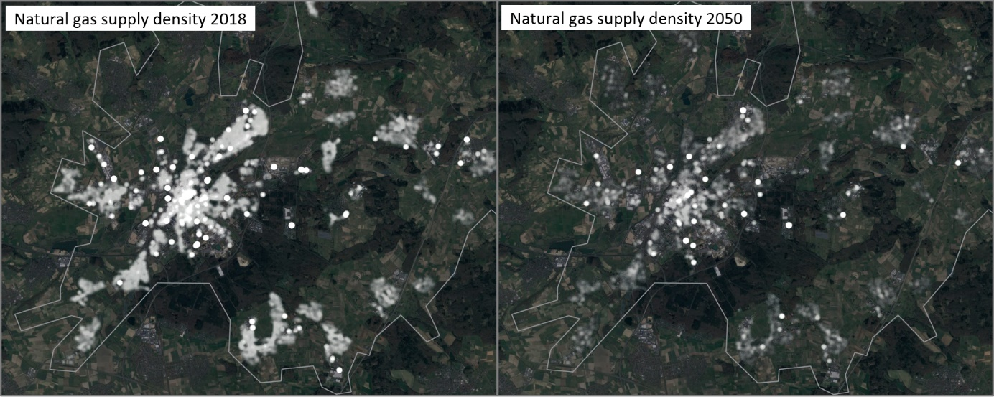

Figure 2: Heatmap representation of today‘s natural gas supply density in the area of study in comparison to natural gas supply density in 2050 if rooftop photovoltaics and heat pumps are widely adopted (own representation)

In addition to the change of spatial characteristics, the effects of the inceasing feed-in from decentralized generation systems can be seen, as the comparison of electrical load profiles in the same scenario shows.



Figure 3: Comparison of the contemporary electrical load profile and the future sum profile for the area of study (own representation)

Using the approach presented it was possible to differentiate between future electricity requirements and district heating and gas supply density in urban and rural areas. Furthermore, the scenarios that preferred a low-emission energy supply to the area of study always lead to greatly increased electricity demands which could not be covered by the existing rooftop photovoltaic potential. This increase was mainly due to high usage of heat pumps as well as electrification of individual transport.

Literature

|  |  |
| --- | --- |
| [1] | Building footprint and DEM data provided by the Hessian Adminstration for Ground Management and Geo-Information. <https://hvbg.hessen.de>, 2019 |
| [2] | Energy consumption data provided by Stadtwerke Giessen AG (<https://www.swg-konzern.de>) and Mittelhessen Netz GmbH (<https://www.mit-n.de>) as part of the research project Kommun:E (<https://www.thm.de/etem/forschung/projekte/drittmittelprojekte/laufende-projekte/transformation-kommunaler-energieversorgungs-infrastrukuren-unter-dem-einfluss-dem-einfluss-der-deutschen-einergiewende.html>), 2019 |
| [3] | LiDAR data provided by the Hessian Ministry of Economics, Energy, Transport and Housing. <https://www.energieland.hessen.de/solar-kataster>, 2019 |

1. Wiesenstraße 14, 35390 Gießen, +49 641 309 2189, hannes.koch@me.thm.de, <https://www.thm.de/me/hannes-koch>
2. The area around the city of Gießen, Germany.