Derivation of future intraday price series from the outputs of energy system modelling
(3) Integrierte Netze der Zukunft
Ryan HARPER⁽¹⁾, Timo KERN^{(1),} Serafin VON ROON⁽¹⁾
⁽¹⁾FfE München

Motivation
As the German energy system continues to be transformed over the course of the Energiewende, the share of electricity generated by volatile renewable sources will also continue to rise. In turn, this will result in increasing importance of, and trading on, the intraday market [1]. The volume of electricity traded on this market has already increased by 300 % between 2012 and 2018 [2]. Beyond its importance for correcting generation and load imbalances, intraday trading also offers opportunities for arbitrage, allowing traders or operators of flexible devices to profit from price differences that may emerge between the day-ahead and intraday markets or between the intraday auction and continuous trading [3] [4]. Successfully capturing these revenues is key to integrating flexible units, such as electric vehicles capable of bidirectional charging, into the energy system and smoothing the volatility of renewable generation [5]. To assist the development of profitable future intraday trading strategies, prices on the continuous intraday market will be derived from modelled future prices, obtained from the FfE energy system model ISAaR, for the year 2030.
Methods
A time series of continuous intraday electricity prices will be generated using the results of energy system modelling and a Markov chain for the stochastic selection of price deviations. The model ISAaR provides input data, including conventional and renewable generation, load, residual load, and day-ahead electricity prices for 2030. The influence of such factors upon the variations between day-ahead and intraday prices are examined using additional historical time series data from 2018-2020, and relevant factors are selected for the determination of future prices (Step 1a in Figure 1). The historical price variations under consideration of various levels of the influencing factors (e.g., high vs. low residual load) are also categorized (e.g., high/low negative variation, high/low positive variation) in Step 1b. The factors, their levels, and the variation categories are carried over for the creation of future prices in combination with the output of the energy system model.

To obtain stochastic variations within the ranges of the observed variation categories, and to reflect the temporal linkages between price variations of consecutive time steps, the price variations will be drawn using a Markov chain. Transition probabilities for each variation category are calculated from the historical data for all levels of each selected influence factor (Step 2 in Figure 1). For each time step in 2030 the current state of the influencing factor, as determined in ISAaR, and the category of the price variation from the previous time step together determine which transition probability from step 2 is used to draw each new price variation in step 3. These price variations are then summed with the corresponding day-ahead prices from ISAaR in step 4 to obtain a time series of continuous intraday prices for the year 2030. This description concerned the calculation of hourly continuous intraday prices based on deviations from the day-ahead market, but the method is used in the same manner to obtain quarter-hourly continuous prices using deviations from the intraday auction.
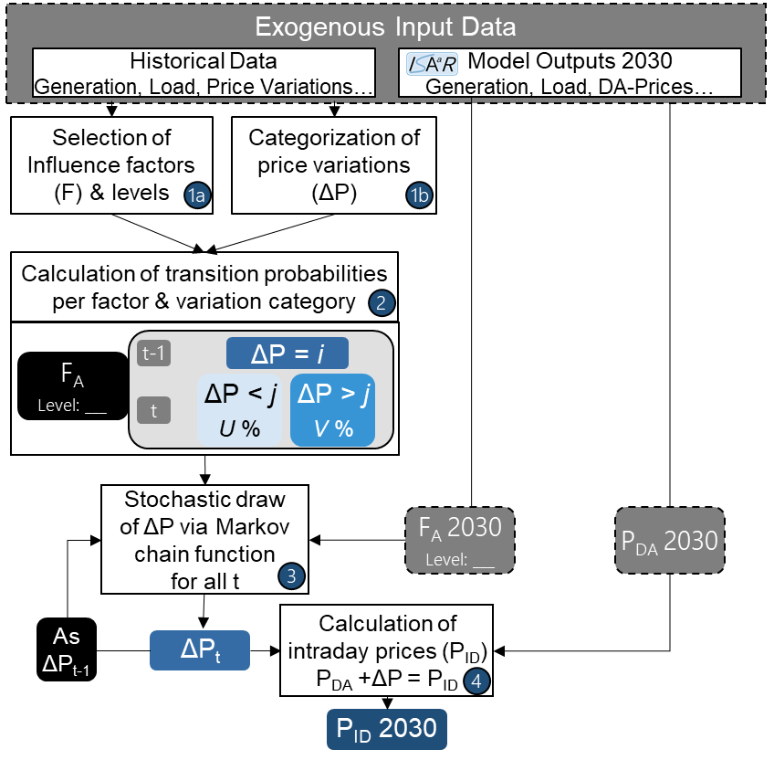
Figure 1: Overview of the described methodology

Results
Statistical analysis of the historical data identified the residual load, which also captures the influences of other potential factors (i.e., time of day, load, and conventional and renewable generation), as the most appropriate influencing factor. Therefore, the Markov chain function is based upon the different residual load levels observed in the historical data. Calculations show that the described method is capable of producing price variations with similar qualities to those observed in the historical data. Thus, this method also appears suitable for building time series of future continuous intraday prices using the modelled day-ahead prices, or intraday auction prices, and residual load values. In further steps, the described method can be used to evaluate potential future revenues for existing flexibility providers in different future scenarios, such as various degrees of market penetration by renewable generation.
Literature
[1] | Kath, Christopher; Ziel, Florian.: The value of forecasts: Quantifying the economic  Gains of accurate quarter-hourly electricity price forecasts. Eneeco (2018),  doi:10.1016/j.eneco.2018.10.005
[2] | Kern, Timo et al.: The value of intraday electricity trading – Evaluating situation-dependent opportunity costs of flexible assets. München: Forschungsgesellschaft für Energiewirtschaft mbH, 2019.
[3] | Maciejowska K et al.: Day-Ahead vs. Intraday—Forecasting the Price Spread to Maximize Economic Benefits. Energies. 2019; 12(4):631. https://doi.org/10.3390/en12040631
[4] | von Roon, Serafin et al.: Limitierte Gebote im Day-Ahead Handel als Maß für Liquidität und Preisaufschlag im Intraday-Markt. München: Forschungsgesellschaft für Energiewirtschaft mbH, 2015.
[5] | Kern, Timo et al.: Integrating Bidirectionally Chargeable Electric Vehicles into the Electricity Markets. Basel, Switzerland: Energies 2020, 13(21), 5812, 2020.

Am Blütenanger 71, 80995 München, +49 (0)89 158121-67, rharper@ffe.de

