Agent-based model of net-zero integrated retrofitting of neighbourhoods

Energie in Gebäuden
Ardak AKHATOVA⁽¹⁾, Lukas KRANZL⁽¹⁾
⁽¹⁾EEG, TU Wien

Motivation and Aims
The current rate (0.4-1.2%) and depth of building retrofitting across Europe are insufficient to achieve the Paris agreement [1]. New approaches are necessary to accelerate the process of retrofitting. Mass retrofitting using prefabricated facades and roofs [2] to net-zero energy performance, combined with innovative business models (performance guarantee in „Energiesprong“ [3], offer of integrated retrofitting packages by One-Stop-Shops [4,5], group purchases of retrofitting materials [6]) can be a promising solution. However, there are many open questions, one of those being: What socio-techno-economic conditions facilitate the diffusion of net-zero retrofitting packages among building owners in a neighborhood? The article is the first attempt in developing the agent-based diffusion model that will attempt to answer this question.
Methodology
Agent-based model (ABM) is a computer simulation of an artificial world populated by agents – discrete decision-making entities (individual, household, firm, etc.). ABM allows to incorporate heterogeneity and adaptivity of energy consumers [6] and is well-suited for modelling the complex interactions between heterogeneous agents with different goals and characteristics [7]. The realisation of integrated net-zero energy retrofitting that we want to analyse is an example of such complex multi-stakeholder systems (see Figure 1).
The conceptualisation and implementation of an agent-based model is known to be challenging. Moreover, there are very few agent-based models related to energy-efficient retrofitting [8,9]. Therefore, we will first conduct a small literature review to learn: (a) how ABM has been used to study energy-efficient retrofitting; (b) how building owners‘ decisions regarding retrofitting is modelled. Then, based on the previous conceptual model presented by the authors [10], we describe how our ABM of net-zero retrofitting decisions functions, including who the agents are, what actions they perform based on what „rules“ and parameters, and how the simulation outcomes are evaluated. Finally, a basic model will be implemented using Python Mesa (i.e. package for agent-based simulation).
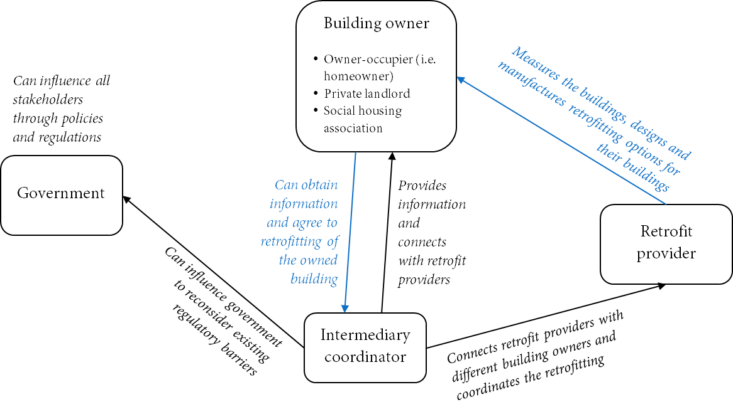
Figure 1. Relationships of the key stakeholders
Results and Discussion
In the ABM of net-zero retrofitting, „intermediary agents“ inform the building owners in one neighborhood about the opportunity to retrofit their dwellings. Building owners can choose a retrofitting package based on their „decision-making framework“ (i.e. rules, algorithm) that considers the factors that influence their (investment) decisions regarding retrofitting (e.g. capital investments, perceived payback period, other non-monetary benefits). Retrofitting packages will be identified using the sub-model „techno-economic evaluation of retrofitting packages“ based on the existing building archetypes of the Tabula project [11]. The retrofitting options will be clustered to three main groups: a) building envelope insulation; b) heating system improvements; c) renewable energy generation and storage system installation.
Several scenarios of policy interventions (e.g. changes to regulatory framework of housing, CO2-taxes) will be investigated. Moreover, sensitivity analysis with regards to techno-economic conditions (energy prices and/or CO2-prices, building energy efficiency and type of the building, costs of retrofitting solutions) and socio-economic characteristics in the neighbourhood (building owner’s age, education, income, environmental awareness/attitude, ownership/tenure status, etc). The results will show the number of adopters, the retrofitting solutions adopted, energy and emissions saving achieved, and the annual renewable energy generation. The preliminary flow-chart of the simulation is displayed in Figure 2.
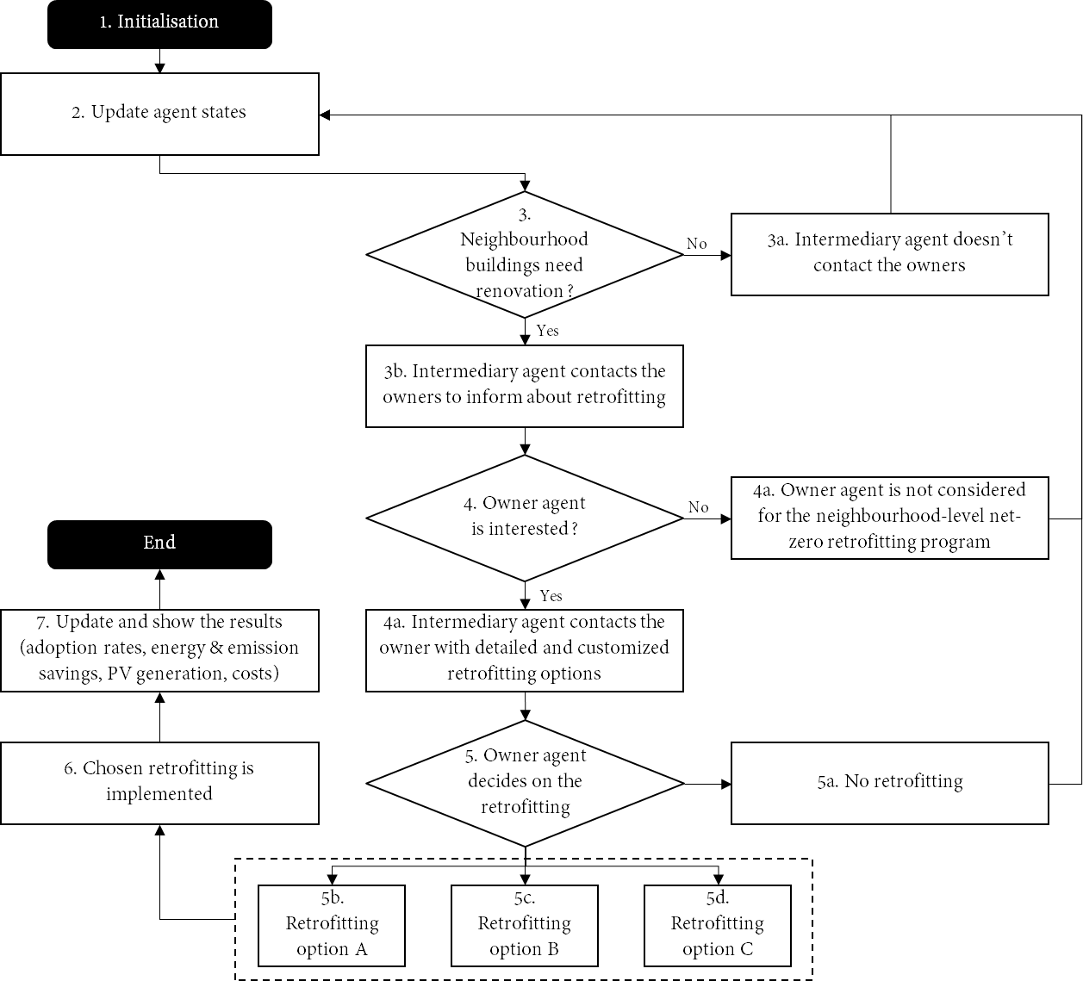
Figure 2. Simulation flowchart
Literature
1. European Commission. Comprehensive study of building energy renovation activities and the uptake of nearly zero-energy buildings in the EU Final report. www.navigant.com (2019).
2. Rovers, R. et al. A Guide Into Renovation Package Concepts for Mass Retrofit of Different Types of Buildings With Prefabricated Elements for (n)ZEB Performance. (2018).
3. Brown, D., Kivimaa, P. & Sorrell, S. An energy leap? Business model innovation and intermediation in the ‘Energiesprong’ retrofit initiative. Energy Res. Soc. Sci. 58, 101253 (2019).
4. Boza-Kiss, B. & Bertoldi, P. One-stop-shops for energy renovations of buildings. 69 (2018).
5. Cicmanova, J., Eisermann, M. & Maraquin, T. HOW TO SET UP A ONE-STOP-SHOP FOR INTEGRATED HOME ENERGY RENOVATION? A step-by-step guide for local authorities. www.dianemorel.com (2020).
6. Ruelle, C. & Teller, J. Guided group purchases of energy renovation services and works in deprived urban neighbourhoods. Energy Effic. 9, 861–874 (2016).
7. Akhatova, A., Kranzl, L., Schipfer, F. & Heendeniya, C. B. Agent-based modelling of urban and district energy systems – A systematic literature review. (2021).
8. Moglia, M., Podkalicka, A. & McGregor, J. An agent-based model of residential energy efficiency adoption. JASSS 21, (2018).
9. Liang, X., Yu, T., Hong, J. & Shen, G. Q. Making incentive policies more effective: An agent-based model for energy-efficiency retrofit in China. Energy Policy 126, 177–189 (2019).
10. Akhatova, A., Kranzl, L. & Fouladvand, J. CONCEPTUAL AGENT-BASED MODEL OF NEIGHBOURHOOD-LEVEL BUILDING RETROFITS BASED ON ENERGIESPRONG APPROACH. in IAEE Online 2021 (2021).
11. Institut Wohnen und Umwelt GmbH. Building Typology. https://episcope.eu/building-typology/ (2016).

Karlsplatz 13, A-1040 Wien, +43 660 264 0155, ardak.akhatova@tuwien.ac.at

