DHexpPot: A sensitivity analysis model on district heating potentials & costs
Integrierte Netze der Zukunft
Mostafa Fallahnejad ⁽¹⁾
⁽¹⁾ TU Wien – Energy Economics Group

Motivation and research question
From economic and environmental points of view, district heating (DH) should be based on the low cost and low emission heat generation. Besides that, in order to keep the DH system competitive, the summation of heat generation and distribution costs should be well below the cost of other heat supply options. The implementation of a DH system and DH grid is capital intensive and requires long-term commitments. The generation side is rather a local theme that may differ from place to place depending on the availability of heat sources. The DH potential and required grid investment, on the other hand, can be studied by looking into the heat demand levels and by using the existing methods. In this paper, the grid related aspects of implementing DH system is studied in detail. An approach for estimation of present value of the existing grid infrastructure is introduced and economic aspects of expansion of DH grids are investigated. We look into gird-related O&M costs and requirements for the re-investments in the grid. The impact of the plot ration and increasing DH market share is discussed qualitatively as a base for the proposed method.
The methodology will be implemented as a calculation module (CM) in the scope of the H2020 project EnerMaps [1] and will be available as DHexpPot CM in its Data Mangement Tool (DMT). DHexpPot will additionally assist users with sensitivity analyses on grid-related parameters.

Approach

To estimate the DH distribution capital cost, several independent input data such as pipe diameter, construction costs, interest rate, etc. are required. Persson et al. introduced a methodology to estimate the distribution capital costs in status quo (Persson and Werner 2011; Persson et al. 2019). Subsequently, the capital costs in each pixel of the map is obtained using the following Formula.

$$w=A/L=\left\{\begin{aligned}137.5*e+5 0.0≤e≤0.4 \\ 60 0.4<e\end{aligned}\right.$$
$$d_{a}=0.0486⋅\ln\left({Q_{T}}/L\right)+0.0007$$

A Land area [m²]
W Effective width [m]
e Plot ratio [-]
Inv_{T} Annualized distribution grid cost per unit of delivered heat [€/GJ]
L Total trench length [m]
C_{1,T} Construction cost constant [€/m]
C_{2,T} Construction cost coefficient [€/m²]
d_{a} Pipe diameter [m]
n Depreciation time
Q_{T} Heat demand supplied by DH in year “T” [GJ]
r Interest rate

To apply this method uniformly to the whole country, uniform data on heat demand densities and gross floor area densities are required. These data are obtained from Hotmaps open source data set [2].
The construction cost constant and construction cost coefficient are different for different countries. The values can be obtained from the H2020 project sEEnergies [3]. Service pipes are referred to the pipes that connect the DH distribution grid to the buildings. Inclusion of service pipes in the overall costs provides a realistic picture of the total investment.
The market share will increase gradually until the end of the investment period. Without re-investment in the grid and by reaching the end of the lifetime of pipes, the market share will reduce. In order to maintain the market share, re-investment in the grid is crucial.

Figure 1: development of the market share with and without re-investment in the grid.

Results
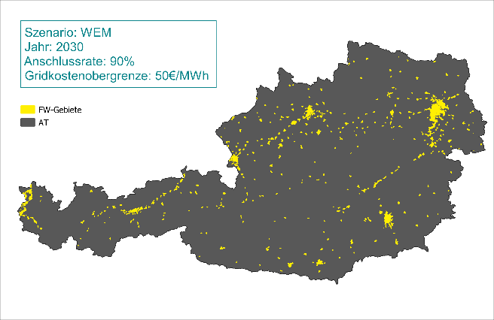
Using DHexpPot it is possible to perform sensitivity analyses on different parameters of DH grid system and study their impact on the DH potential and grid costs. The outputs are shown in form of potential maps as well as charts showing the results of the sensitivity analyses.
Figure 2: Potential DH areas in Austria under a given scenario.

Literatur
[1] H2020 project EnerMaps, https://www.enermaps.eu/
[2] H2020 project Hotmaps, https://www.hotmaps-project.eu/
[3] H2020 project sEEnergies, https://www.seenergies.eu/

Gusshausstrasse 25-29/E370-3, 1040 Wien, +43158801370374, fallahnejad@eeg.tuwien.ac.at, https://eeg.tuwien.ac.at

