The influence of local optimised energy communities on the European electricity market
(4) Active end-user/prosumer participation
Christoph LOSCHAN⁽¹⁾, Daniel SCHWABENEDER⁽¹⁾
⁽¹⁾ TU Wien - ESEA

Motivation and Guiding Question
With its "Clean Energy for all Europeans" package, the European Union has created a legal basis to enable energy communities (EC) in the individual member states. These create incentives for private investments into renewable energies, promoting rapid decarbonisation of the entire energy system. Consumers can reduce their dependence on the electricity market, offer their individual loads as demand-side-management flexibilities, e.g. heat pumps or electric vehicles, and thus benefit from lower grid fees, as the required energy is provided by power plants within the EC. Selling energy within the EC improves the economic efficiency of investments, as the economic difference between self-consumption and feeding into the grid is significantly reduced by self-consumption within the EC.
This paper analyses the influence of ECs, with different local objective functions on the European electricity market, as well as the interactions between the electricity market and various EC objectives.
Methodical Procedure
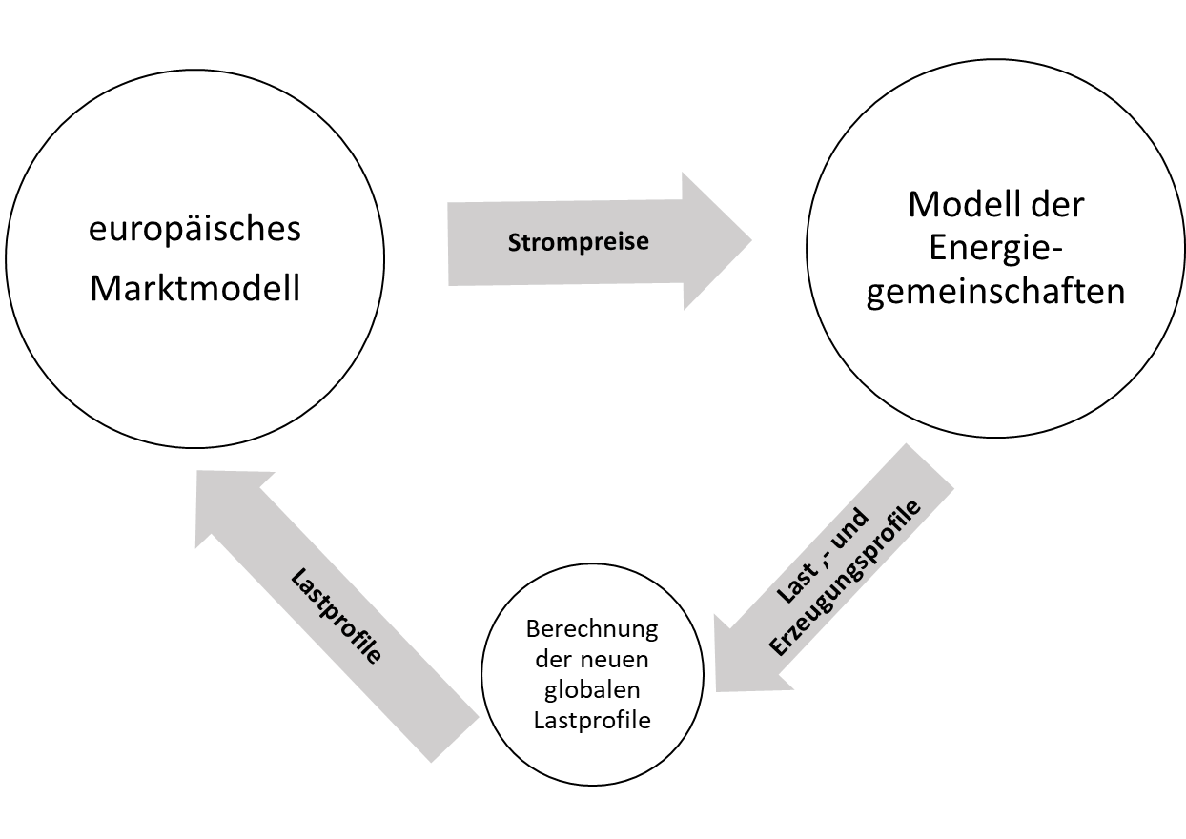
To consider the influence and interactions between the local optima of the ECs and the global goal of minimising costs and CO2 emissions, two models are linked together in a scenario-dependent manner.
Figure 1 Dependence of the models on each other
The European market model EDisOn [1] calculates, based on exogenous demand, - and generation profiles of renewable energies, the optimal power plant dispatch in Europe and, associated with this, the expected electricity prices for the European electricity market. The FEMTO model [2] optimises consumption as well as storage usage within a specific energy community, considering the hourly electricity price of the market as an exogenous time series. Since the global power plant dispatch is influenced by the demand profiles of the ECs, and these in turn by the electricity prices on the spot market, there is a dependency between the two models (see Figure 1).
To analyse the influence of ECs on the electricity market in terms of costs of electricity generation and CO2 emissions, and to consider possible counteracting of local and global targets, different objective functions are considered:
From the energy communities' point of view: (iterative optimisation with a termination criterion)
- Cost minimisation of the energy communities
Implies a solution with very high self-consumption due to grid costs
- Minimisation of energy trading with the electricity market (procurement and feed-in)
Dual problem of maximising self-consumption within the EC
- Peak-shaving
Reduction of maximal power procurement/feed-in from the electricity market to reduce the need for transmission line expansions

From the market perspective: (single run optimisation of the market model)
- Maximising social welfare (Cost minimisation of the European electricity market)
For this purpose, energy storages, available within the ECs are optimised from the perspective of the market and can also be used for the potential procurement of balancing energy. Therefore, the influence of ECs on the balancing energy market is analysed.
Results and Conclusions
The development of the models has not yet been completed, so there are no results available at the moment. However, depending on the scenario, significant differences are expected with regard to costs and emissions from the perspective of the overall system. Local cost minimisation within the ECs is almost independent of the spot market price due to the high grid fees. Therefore, they do not promote the maximisation of the social welfare of the overall system, since energy is not primarily used at those times when it would be available at low costs on the market. On the other hand, optimization from the market perspective, which optimizes ECs as flexibilities, will shift the load so that favourable electricity prices are exploited as effectively as possible. Therefore, reducing the curtailment of renewables and load peaks, to avoid start-up thermal power plants with higher marginal costs will be the main benefits. However, this can have a negative impact on self-consumption within the ECs and thus leads to locally higher costs for demand coverage.

Acknowledgement: This work is done in the “BEYOND” project [3]. The BEYOND project has received funding in the framework of the joint programming initiative ERA-Net Smart Energy Systems, with support from the European Union’s Horizon 2020 research and innovation programme and is an associated project within Green Energy Lab.
Literature
[1] B. Dallinger, 2018, Model-based analysis and design of an improved European electricity market with high shares of renewable generation technologies, Dissertation, http://hdl.handle.net/20.500.12708/1928
[2] D. Schwabeneder, 2021, Business cases of aggregated flexibilities in multiple electricity markets in a European market design, Energy Conversion and Management, Volume 230, https://doi.org/10.1016/j.enconman.2020.113783
[3] "BEYOND” project, [Online], https://beyond-project.eu, [Accessed: 27 Mai 2021].

Gußhausstraße 25 – 29 · 1040 Vienna, +43(0)-1-58801- 370 334, loschan@eeg.tuwien.ac.at, eeg.tuwien.ac.at

