Evaluation of cost-optimal technology portfolio under consideration of autarky
Frida Huglen REVHEIM¹, Daniel SCHWABENEDER¹, Georg LETTNER¹
¹TU Wien - ESEA

Motivation
Energy sector coupling could be a financially viable method to ensure the continued development and operation of renewable energy sources (RES), despite low electricity prices and expiring subsidies making the economic operation and implementation of RES difficult. Autarkic energy systems are able to lower their dependence of external energy resources. However, a high degree of autarky is usually accompanied by high costs for consumers [2]. Through the utilization of energy cells designed for long-term electricity storage, end-users can increase their degree of energy autarky. There is a scarcity of technical and economic experience regarding the interconnected operation of various grid infrastructures. Thus, innovative operating methods must be investigated in order to ensure the continued deployment of RES-based generation and energy storage technologies in the future. Furthermore, cost-optimal technology portfolios under conditions of meeting desired degrees of energy autarky must be evaluated.
Method
This paper builds on work performed within the Energy Cell Johann project [1], where seasonal storage technology with multimodal and multi-functioning applications was investigated. An investigative analysis is performed in order to evaluate the impact of long-term electricity storage, as well as local hydrogen production and sector coupling, on end-users. Particular focus is given to achieving the desired degree of autarky and investment planned modelling is performed in order to evaluate the cost-optimal technology portfolios under the requirement of autarky.

A mathematical optimization model is developed in Julia. An overview of the modelled system is presented in Figure 1. The investigated system enables both power-to-gas and gas-to-power conversion, as well as long-term storage of electricity, through the implementation of technologies such as electrolyser, fuel cell and hydrogen storage unit within the energy cell. It is assumed that hydrogen can be extracted from the energy cell and sold to the hydrogen market, as well as serving as a mean to enable long-term storage of electricity. Waste-heat generated in the process of converting electricity to hydrogen is utilized to aid cover the heat demand of end-customers. The cost-optimal technology portfolio is investigated through an optimization which aims to minimize investment costs while continuously meet the desired degree of energy autarky.

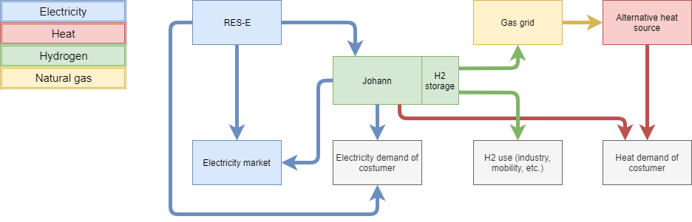
Figure 1: Sector coupling model including the Johann energy cell
Results
The implementation of a controllable energy cell represents a potential solution of prosumer autonomy and enables for a more renewable energy supply. Results related to the influence of long-term electricity storage, local hydrogen production and sector coupling on end-users, particularly regarding economic impact, ability to maintain a certain degree of energy autarky and to reduce greenhouse gas emissions, will depend on comprehensive analyses that will be performed in the course of this work. Further analyses of the cost-optimal technology portfolio will provide insights into optimal system designs for use cases with varying desire for energy autarky.
Acknowledgements: This work is done in the “Energy cell “JOHANN”” project [1] and is supported with the funds from the Climate and Energy Fund and implemented in the framework of the RTI-initiative “Flagship region Energy” within Green Energy Lab.

References

[1] | Green Energy Lab, "Energiezelle „JOHANN“," GEL, [Online]. Available: https://greenenergylab.at/projects/energiezelle-johann/. [Accessed 05 2021].
[2] | J. Schmidt, M. Schönhart, M. Biberacher, T. Guggenberger, S. Hausl, G. Kalt, S. Leduc, I. Schardinger and E. Schmid, "Regional energy autarky: Potentials, costs and consequences for an Austrian region," Energy Policy, vol. 47, no. 0301-4215, pp. 211-221, 2012.

https://julialang.org/

