Chances and barriers for Germany’s low carbon transition - Quantifying uncertainties in key influential factors
Themenbereich: (5) (Open-Source) Modellierung

Konstantin LÖFFLER^{(1,2)}, Thorsten BURANDT^{(1,2,3,4)}, Karlo HAINSCH⁽¹⁾, Pao-Yu OEI^{(1,2,3)}, Frederik SEEHAUS⁽¹⁾, Felix WEJDA⁽¹⁾

⁽¹⁾ Workgroup for Infrastructure Policy, Technische Universität Berlin, Germany,
⁽²⁾ German Institute for Economic Research, Berlin, Germany,
⁽³⁾ Europa-Universität Flensburg, Flensburg, Germany,
⁽⁴⁾ Department of Industrial Economics and Technology Management, NTNU, Trondheim, Norway

Motivation
With the energy sector being one of the largest sources of global greenhouse gas emissions, a swift change in the ways of energy generation and consumption is needed for a fulfilment of climate goals. But while the existence of global warming and the resulting need for action are widely agreed upon, there is a lot of discussion around the concrete measures and their timeline. A major cause of this discussion is that of uncertainty, both with regard to possible outcomes, as well as to a multitude of factors such as future technology innovation (concerning both availability and costs), and final energy demands, but also socio-economic factors such as employment or sufficiency.

Methodology
This paper aims to give valuable insights into this uncertainty by applying the method of exploratory sensitivity analysis to an application of the Global Energy System Model (GENeSYS-MOD) (see Löffler et al. 2017, Burandt et al. 2018) for the German energy system. By computing over 1500 sensitivities across 11 core parameters, the key influential factors for the German Energiewende can be quantified, and possible chances, such as so-called no-regret options, as well as potentials barriers (if assumptions are not met) can be distilled. In this exploratory sensitivity analysis, a wide range of key parameters to the model is changed iteratively, yielding a total of 1591 separate sensitivities that have been considered in this study. All of these sensitivity results are then cross-compared with each other, as well as with a defined reference scenario, or base case. This reference scenario is based on a previous study with GENeSYS-MOD for Germany (Bartholdsen et al. 2019).
To achieve this, GENeSYS-MOD was expanded with a new module that enables this exploratory sensitivity analysis, adding the functionality to vary key input parameters via automated scripts that can then be used to run a multitude of sensitivities in parallel.

Results and Conclusions
Results show that especially demand reduction plays a tremendous role in the process of reaching climate targets (see Figure 1). Across all analyzed result values, changes in final energy demand heavily impacted the model results to achieve ambitious reduction targets by 2050, with an especially pronounced effect in the buildings sector. Also, the costs and available potentials of RES have a significant impact on generation costs, necessity of grid expansion, and the distribution of generation capacity across Germany. The choice of a price on emissions has a noticeable effect in the near to intermediate future, heavily reducing cumulative emissions since action is taken sooner, especially in the industrial sector. Overall, large-scale investments into renewable energies and storages are a no-regret-option for climate targets and often prove to be minimum requirements for other technologies to succeed. For the analyzed German case study a reduction of 88% by 2050 (compared to 1990) was calculated, clearly missing the German (and European) target of climate neutrality. The obtained sensitivity pathways (changing always just one parameter) reach reduction values of 75 - 95% - showing that additional efforts in more than one domain are needed to allow for a faster decarbonization pathway. Thus, one can only underline the importance of immediate action that needs to undergo for a successful low-carbon transition.
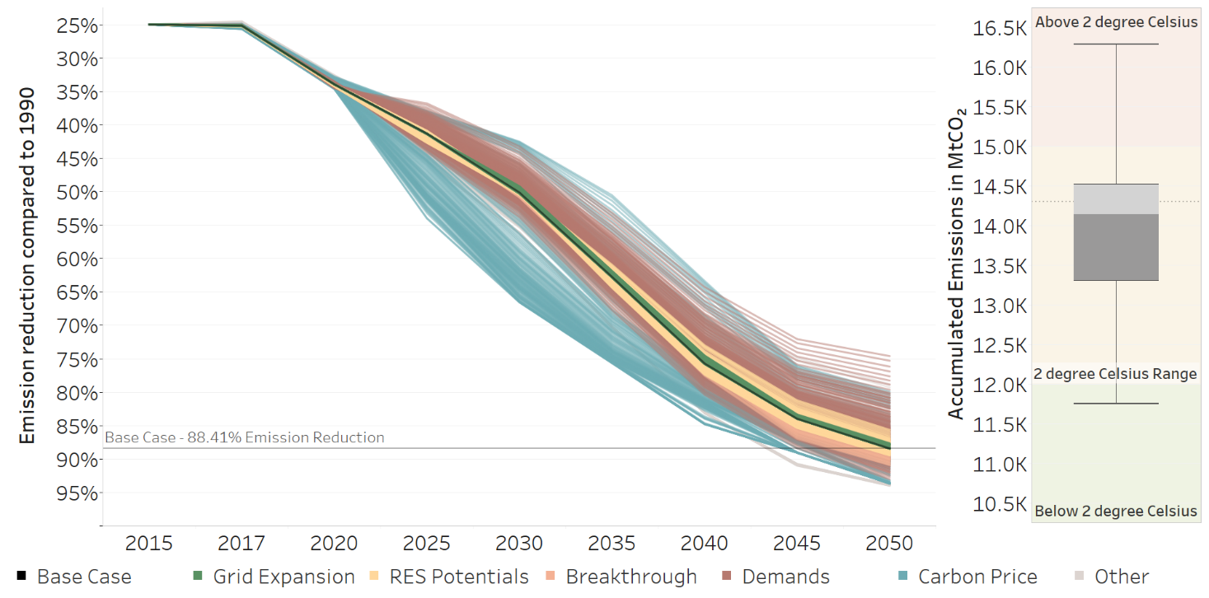
Figure 1: Spread of emission reductions compared to 1990 across all tested sensitivities (left)
and spread of accumulated emissions in 2050 across all sensitivities (right).

References
Bartholdsen, H.-K., A. Eidens, K. Löffler, F. Seehaus, F. Wejda, T. Burandt, P.-Y. Oei, C. Kemfert, and C. von Hirschhausen. 2019. „Pathways for Germany’s Low-Carbon Energy Transformation Towards 2050.“ Energies 12 (15): 2988. https://doi.org/10.3390/en12152988.
Burandt, T., K. Löffler, and K. Hainsch. 2018. „GENeSYS-MOD v2.0 - Enhancing the Global Energy System Model.“ DIW Data Documentation 94.
Löffler, K., K. Hainsch, T. Burandt, P.-Y. Oei, C. Kemfert, and C. Von Hirschhausen. 2017. „Designing a Model for the Global Energy System—GENeSYS-MOD: An Application of the Open-Source Energy Modeling System (OSeMOSYS).“ Energies 10 (10): 1468. https://doi.org/10.3390/en10101468.

Jungautor, Straße des 17. Juni 135, 10629 Berlin, Deutschland, +49 30 31425139, kl@wip.tu-berlin.de

