On the way to low-emission European buildings: investigating the role of non-ETS CO2 pricing in the residential and tertiary sectors
Themenbereich 8: Energie in Gebäuden
Şirin ALIBAŞ⁽¹⁾, Tobias FLEITER⁽¹⁾, Pia MANZ⁽¹⁾, Rainer Elsland⁽¹⁾
⁽¹⁾Fraunhofer ISI

Motivation und zentrale Fragestellung
The review of the Paris Agreement in December 2020 necessitates that the EU member states reduce their greenhouse gas emissions to 55% of 1990 levels by 2030. It is also clear that in order to limit the global warming to 1.5°C, the EU should be climate-neutral by 2050 (European Commission, 2020a). According to European Commission’s Impact Assessment, CO₂ pricing in buildings can be an effective instrument, but has certain limitations. While keeping the energy efficiency and renewable energy policies continued at the currently planned pace, the modelled 60€/t CO₂ pricing cannot overcome the barriers to reach climate-neutrality by 2050, “or might need to be very high to achieve the outcome” (European Commission, 2020b). Therefore, it is worth to investigate the limits of CO₂ pricing as a decarbonisation measure in the building sector.

Methodische Vorgangsweise
Here, we make an analysis of where the EU building sector is heading from the planned perspective and we conduct a CO₂ price sensitivity analysis with a demand simulation model. The simulation model FORECAST is used to simulate the scenario pathways. FORECAST models the building stock based on agents and incorporates economic factors such as fuel prices, technology and system costs, as well as policy measures such as subsidies, regulations etc. that drive the investment decisions. Five different CO₂ price pathways are simulated; starting from an average of 14€/t in 2020 and going up to 77, 180, 200, 300 and 350€/t in 2050 (see Table 1).

Table 1: Evolution of the CO₂ price in different pathways (EU average)
Pathway | Unit | 2030 | 2040 | 2050
VAR0 | EUR/t | 47 | 63 | 77
VAR1 | EUR/t | 102 | 142 | 181
VAR 2 | EUR/t | 131 | 166 | 201
VAR 3 | EUR/t | 180 | 240 | 300
VAR 4 | EUR/t | 200 | 275 | 350

Ergebnisse und Schlussfolgerungen
Judging by the projections, buildings could achieve 85% direct emission reduction in 2050 at the current pace of the measures. Under the highest CO₂ price scenario, the emission reduction goes up to 90% in 2050 compared to 1990. The effect of the vast increase of CO₂ price on the emission reduction is marginal. Moreover, even the highest CO₂ price does not lead to a 95% reduction in the emissions, which is the least reduction needed for climate-neutrality of the sector.

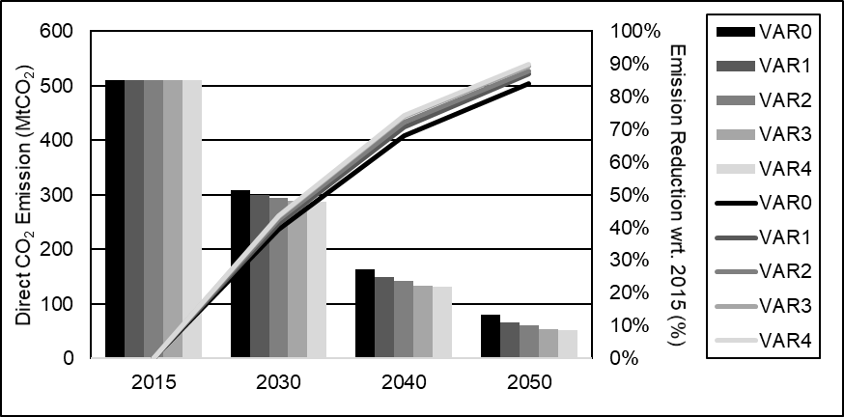
Figure 1: Evolution of direct emissions of EU buildings and reduction compared to 2015 under different scenario pathways

Thus, we observe that even a very high CO₂ price on the fossil fuels used in buildings is not enough to achieve the emission targets in 2050, if the other measures are continued at the current pace. The decarbonisation of the EU building stock would require the implementation of additional accompanying measures that overcome barriers not addressed by the CO₂ price. Looking ahead, it is also worth to investigate how the CO₂ pricing in the electricity and district heating supply affects the energy carrier prices and overall choice of heating technology in buildings.

Keywords
Carbon-neutral buildings; non-ETS CO₂ price; decarbonized EU buildings; CO₂-pathway analysis

Literatur
[1] European Commission (2020a) “The update of the nationally determined contribution of the European Union and its Member States”. Berlin.
[2] European Commission (2020b) “Commission staff working document impact assessment accompanying the document: Communication from the Commission to the European Parliament, the Council, the European Economic and Social Committee and the Committee of the Regions - Stepping up Europe’s 2030 climate ambition: Investing in a climate-neutral future for the benefit of our people”. Brussels.

Breslauer Straße. 48, 76139 Karlsruhe, Germany, +49 721 6809-578, sirin.alibas@isi.fraunhofer.de, www.isi.fraunhofer.de

